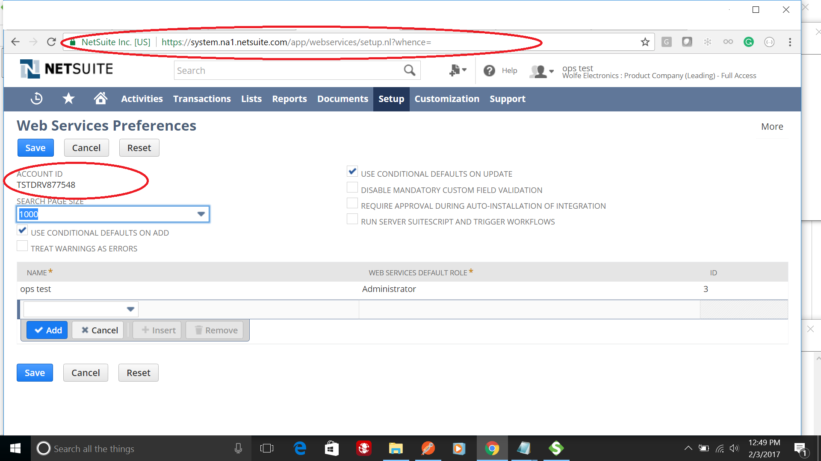
Log into Netsuite with a user with Administrator privilege, setup>Integration>Web Services Preferences. And write down the Account ID circled above.
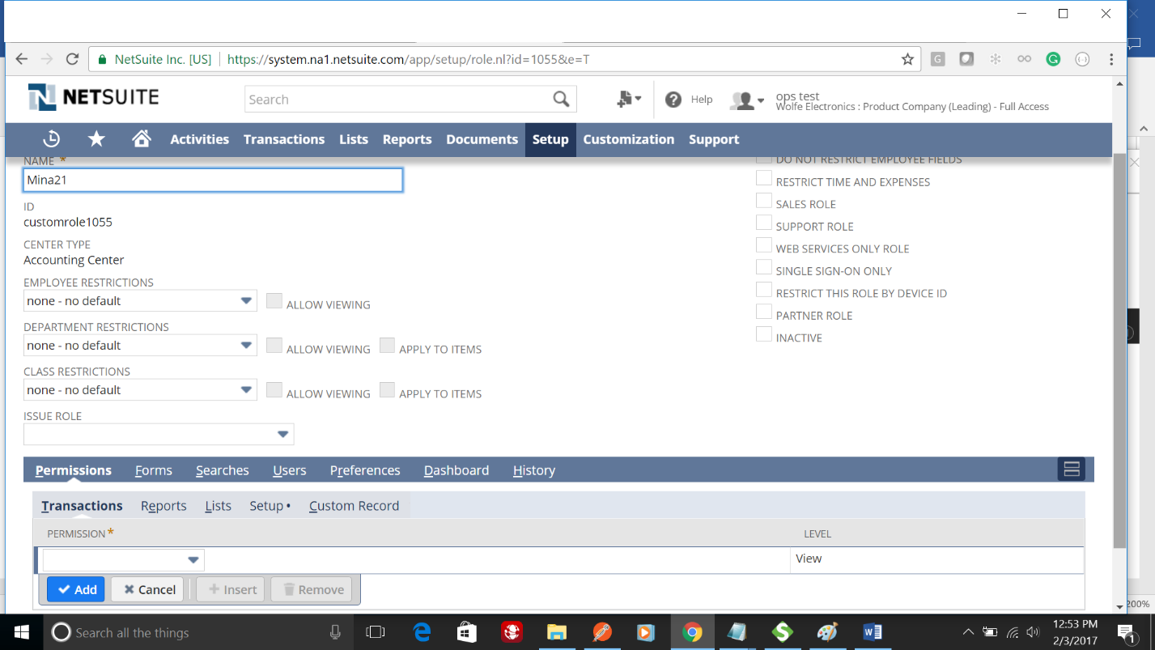
Create a custom role, name it.
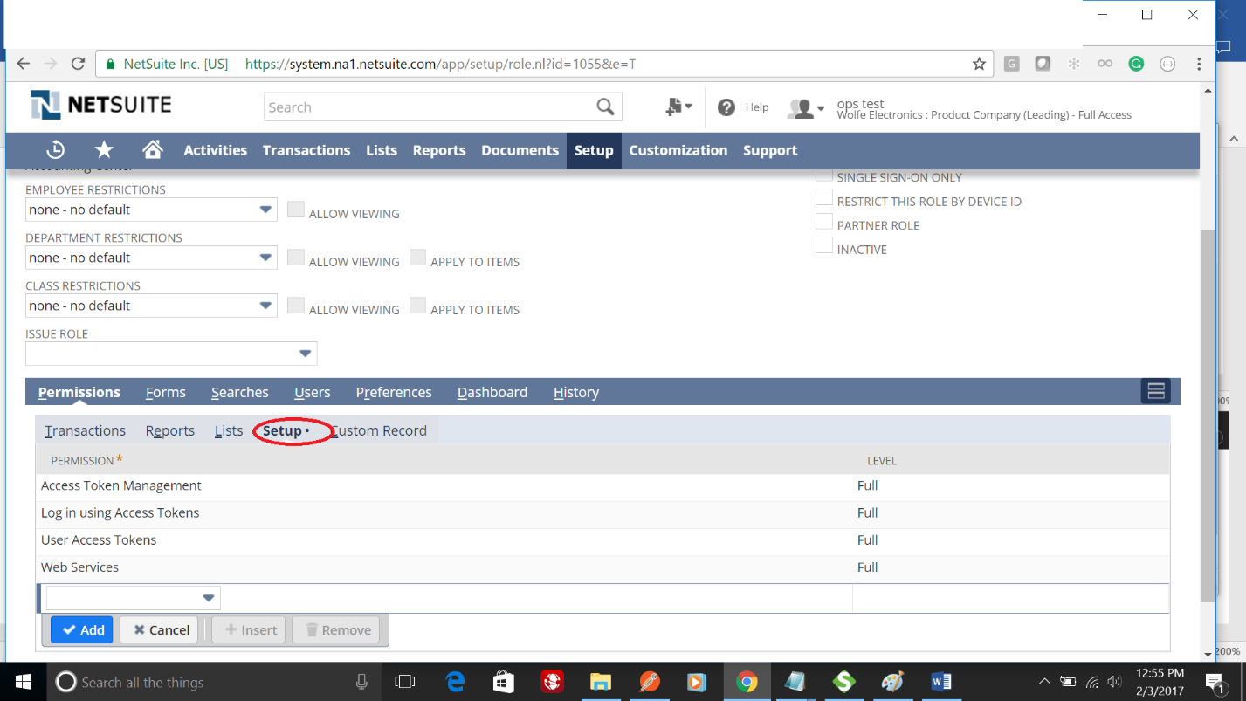
Click Setup of this role and add the above 4 privileges.
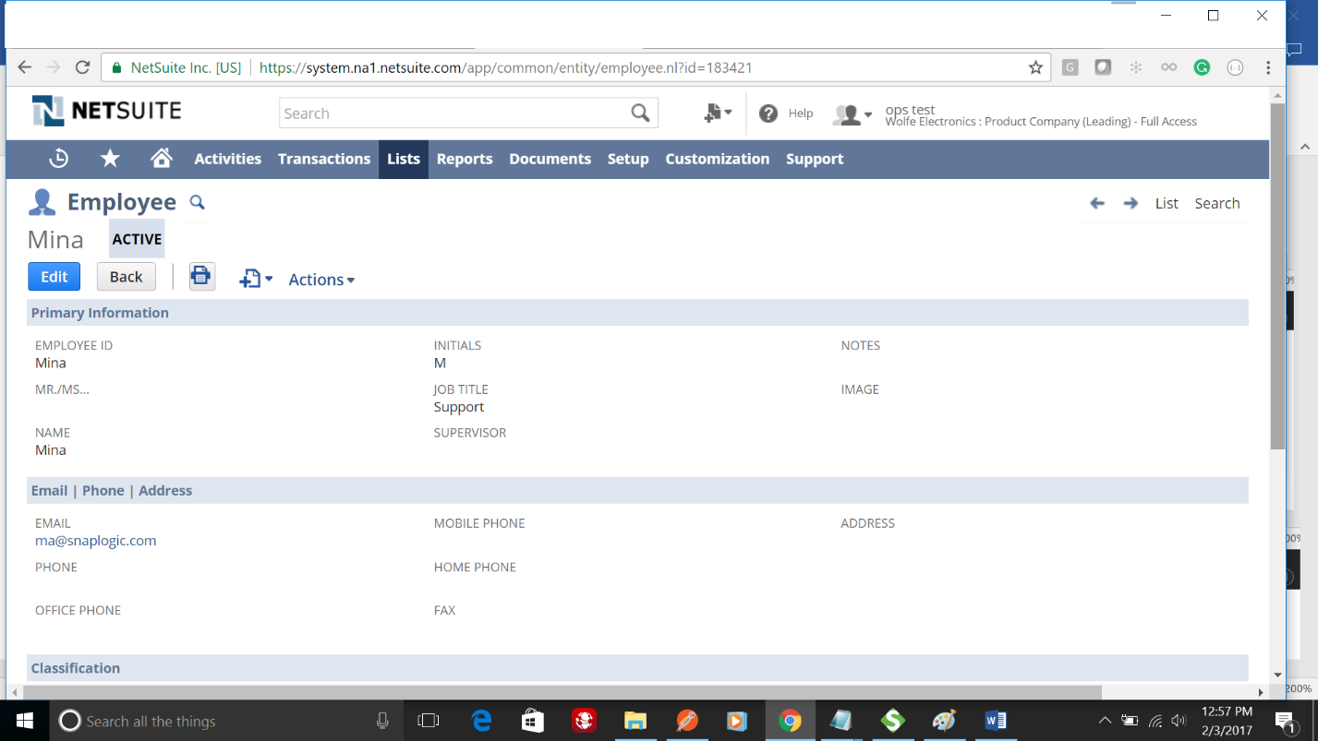
Edit a user.
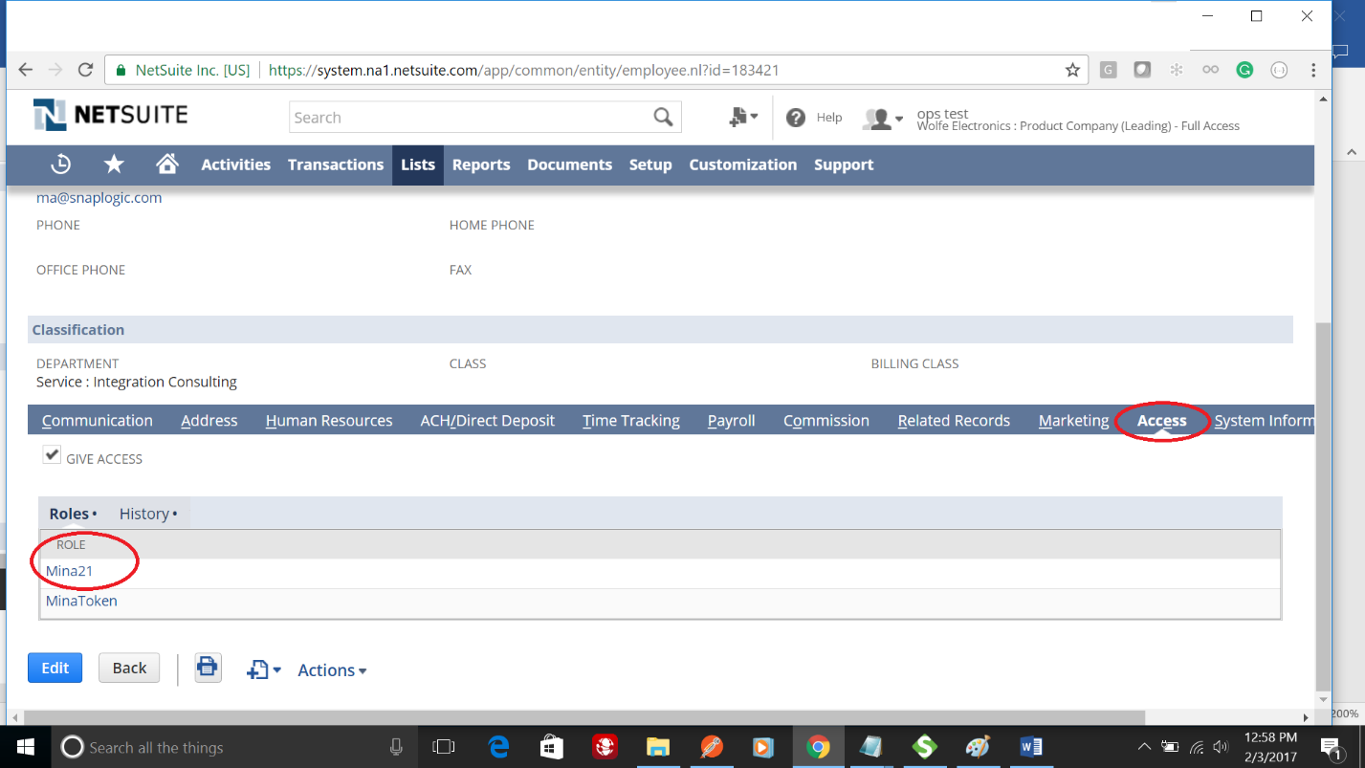
Click its Access tab and make sure the above created role is added. Also make sure the GIVE ACCESS checkbox is checked, it’ll ask for password, enter it twice and Save.
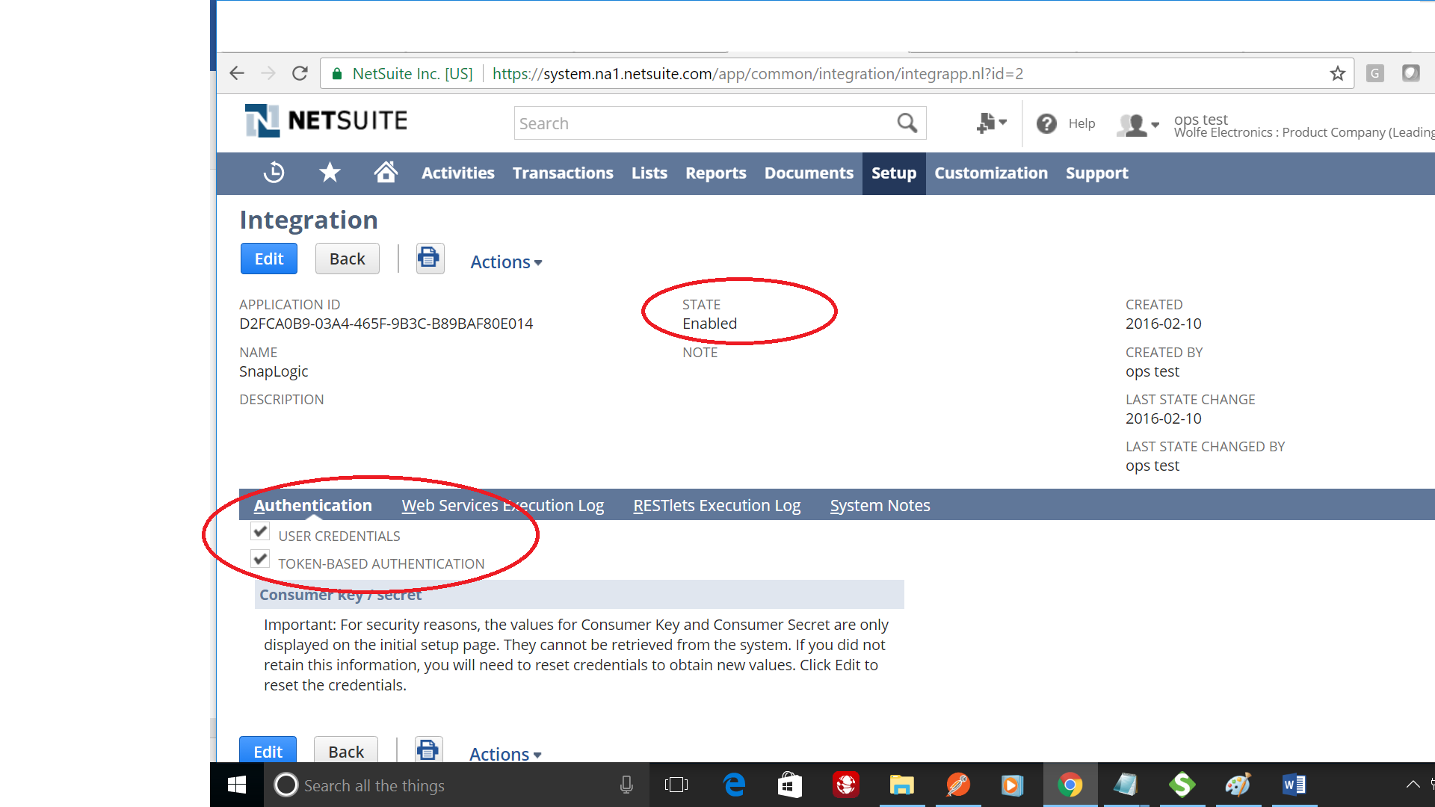
setup>Integration>new Integration>name has to be SnapLogic
Ensure state set to Enabled, Authentication Both User Credentials and Token based Authentication checked, if User Credentials are not checked, invalid login attempt occurs.
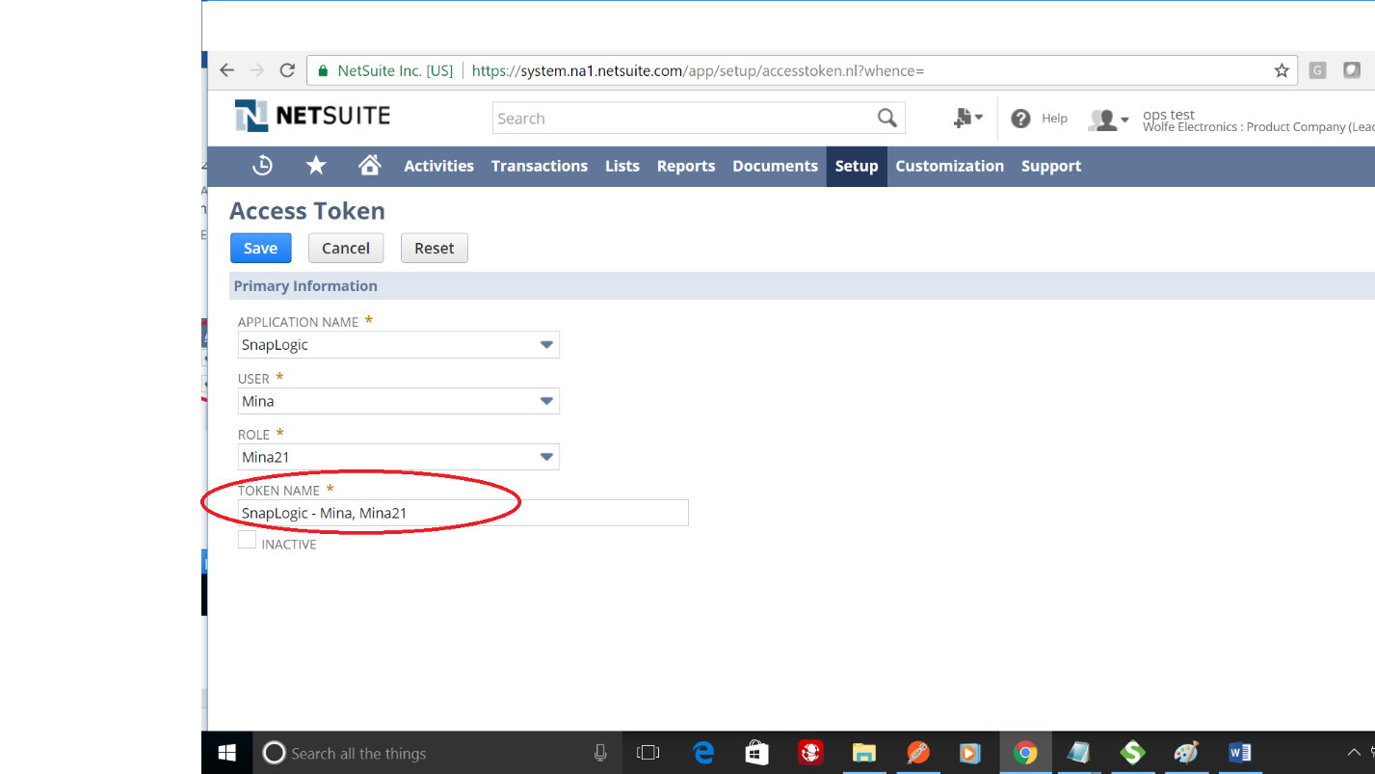
Setup>users and roles>Access Tokens>New
make sure to select the same user, role and SnapLogic Integration.
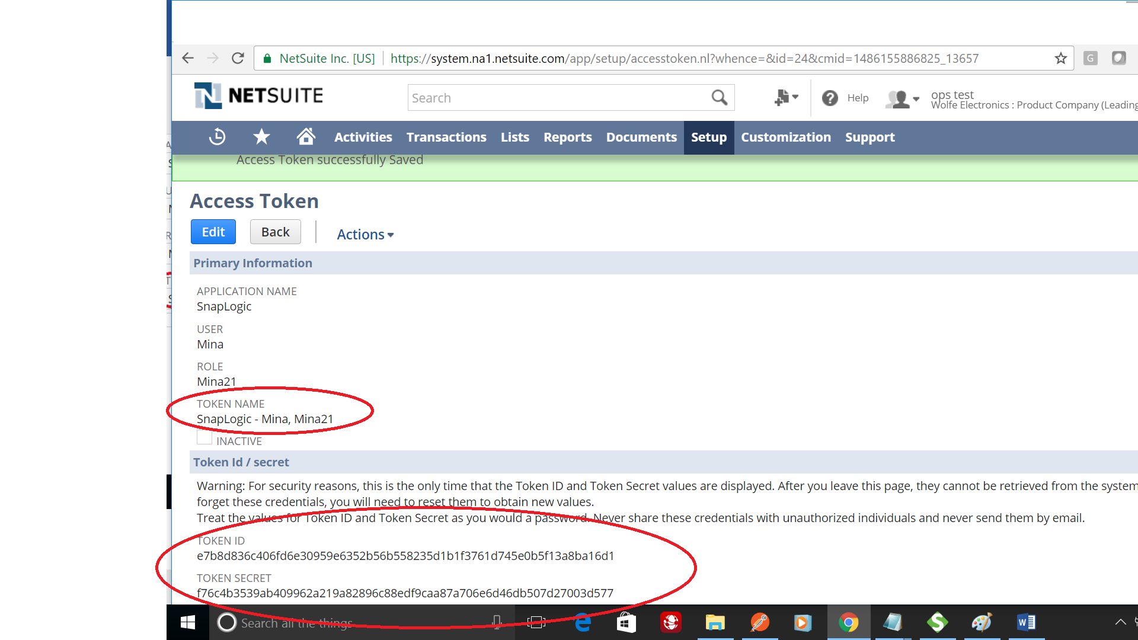
Paste the Account ID and the token id and token secret to SnapLogic, NS Token account.
Account Validation will be successful.

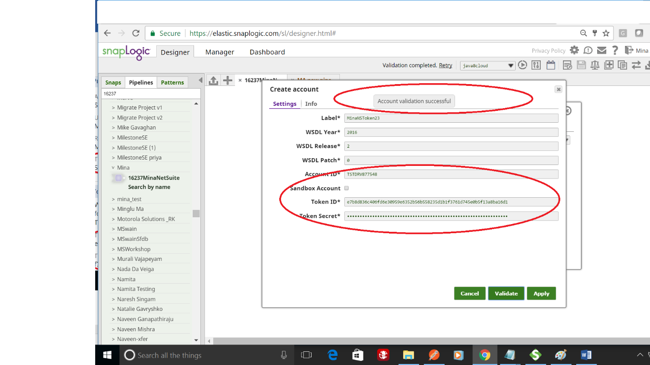

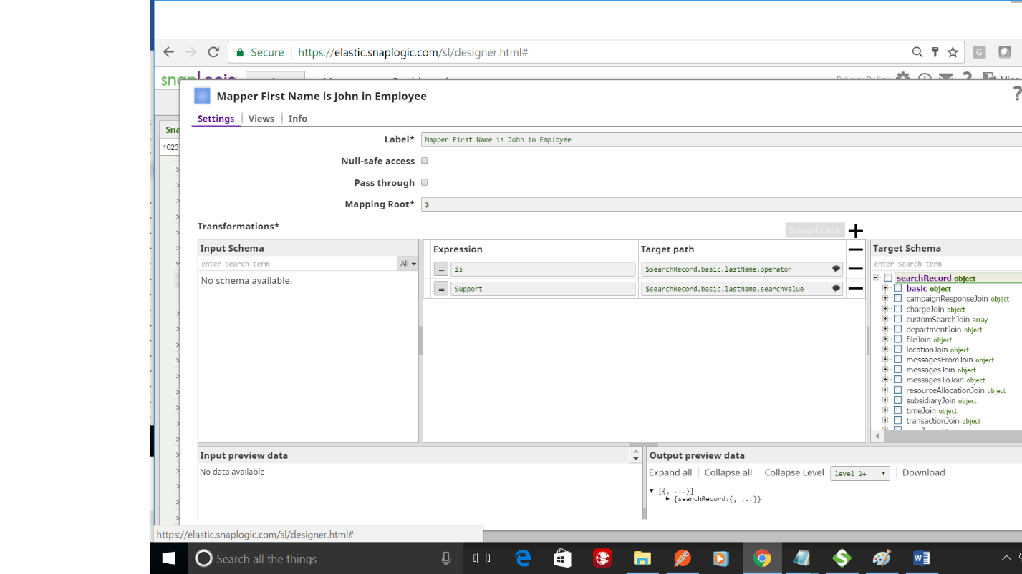
Create a Pipeline with a Mapper snap>Netsuite Search object * set to Employee
The snap will tell you
platformCore:code=INSUFFICIENT_PERMISSION, platformCore:message=Permission Violation: You need the 'Lists -> Employees' permission to access this page
This is because when we created the role, we only give is minimum access privileges
We did not give any data privilege. Could edit the role and add the privilege and regenerate the token id and secret.
